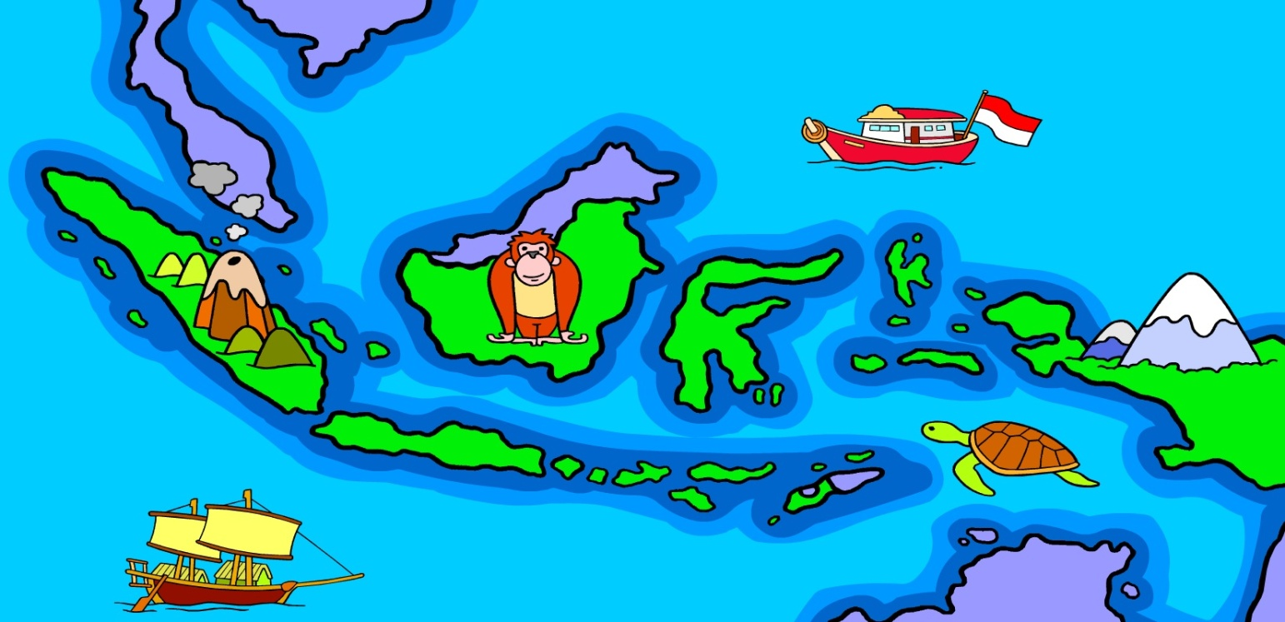

Nama
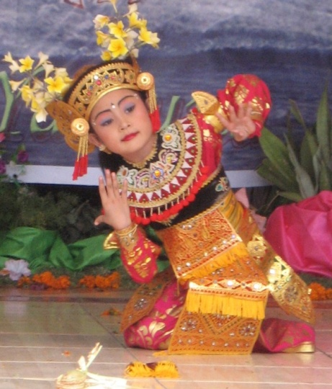
Tanah Airku,
Indonesia

TANAH AIRKU, INDONESIA (My Waterland, Indonesia)

This is a list of the skills you will have in Indonesian (and English) by the end of this task. Tick off each skill when you have definitely mastered it and not before! Then, to see if you have really learned it, check again in 3-4 weeks time. That’s the real test. The way to master these skills is to be an active learner during all lessons, keep up with all your work and homework, and ASK if you don’t understand something. Semoga sukses!

In Indonesian I can … | This week | In 3 weeks
VOCABULARY
Name 10 major islands in Indonesia
Say whether each island is big, small or medium sized
Say any number between 1 and 200 million
State the population of an Indonesian island
Name the capital city of 5 major Indonesian islands
Name 5 famous natural or manmade features of Indonesia
Say on which island each famous feature is located
Name a cultural event from 5 different islands of Indonesia
Name 10 ethnic groups of Indonesian people
State on which island each ethnic group lives
State which language(s) people speak on 5 major islands
State a popular food dish from 5 different islands
SKILLS
Say or write what my name, everyday name and age are; when my birthday is and where I live.
Ask someone else what his/her name, everyday name and age are; when his/her birthday is and where he/she lives.
Write a dot point profile of an Indonesian island
Write a paragraph about an Indonesian island using full sentences and describing four features of the island
Read 5 paragraphs about Indonesian islands and their features, and show your understanding by answering questions
Listen to a description of an Indonesian island and match it to the island’s name
Ask someone 5 questions about an island he has studied
Answer 5 questions about an island you have studied
In English I can …
Compare the geographical features of Indonesia and Australia
Compare some aspects of people and their way of life in Indonesia and Australia

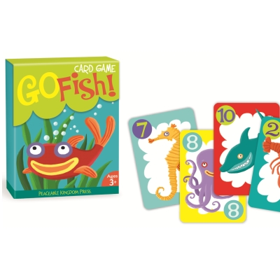
TASK 1: Create a set of 4 playing cards on aspects of one of the islands of
Indonesia. Put your cards together with other students’ cards and play a
game of “Fish” or “Snap”.

Fish is a traditional children’s card game consisting of a pack of cards with sets
of cards of a certain type in it. The idea of the game is to
collect sets of our cards of one type by asking other players
to give you the card you need. You can play it with a normal
deck of cards, or you can use cards with different types of
fish or other things in categories. Our Fish game wll have
the categories Pulau, Orang, Tempat-Tempat and Budaya
(Island, People, Places, Culture)

You can play other games with the cards too, such as Snap.

Your cards will each have a picture and some written information about the island you are studying. Here’s an example of what your cards might look like:

BALI  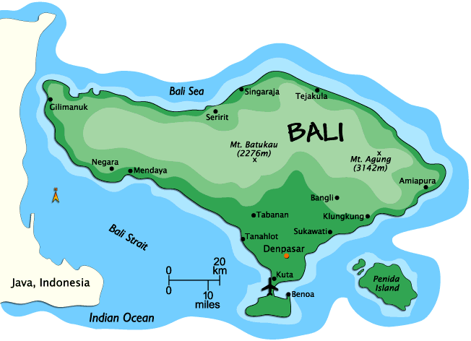  _____________  _____________  _____________  _____________ |  | ORANG BALI  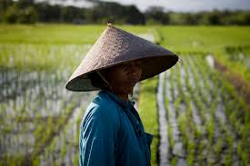  ____________  ____________  ____________  ____________ |  | TEMPAT-TEMPAT  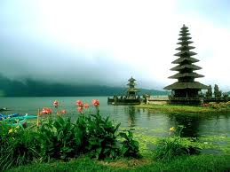  ___________  ___________  ___________  ___________ |  | BUDAYA  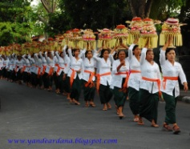  ___________  ___________  ___________  ___________

To make the cards you will create a Word document and do some Internet
research to find photos and information. You will learn how to write that
information in Indonesian as you study this topic.

Your cards will be marked as an assessment, and you’ll also do a couple of short
tests on what you have learned. Here’s how your cards will be marked:

CARDS MARKING KEY

CONTENT | MARKS
You have created 4 playing cards on the 4 topics: island, people, capital and places | /4
Each playing card contains at least 3 separate pieces of information | /12
You have written using mainly the new vocabulary you have learned this year | /4
You have written using correct sentence structures in Indonesian | /5
TOTAL | /25

PLANNING & RESEARCH PAGE
Decide which Indonesian island you are going to research (it must be a different one from all your classmates) and complete the chart below with information that you find out. This will be the basis for writing the information on your set of playing cards.

PULAU (island)

- name
- population
- adjectives to describe it
- capital city

ORANG (people)

- ethnic group
- island they come from
- language

TEMPAT-TEMPAT (places)

- natural feature (1)
- natural feature (2)
- manmade feature (1)
- manmade feature (2)

BUDAYA (culture)

- festival / celebration (1)
- festival / celebration (2)
- festival/ celebration 3)

TANAH AIRKU, INDONESIA

Indonesians love to call their country “Tanah Airku”. This phrase is used in many of their famous national songs. Here are the lyrics of a couple of them.

INDONESIA RAYA (National Anthem)  Indonesia tanah airku,  Tanah tumpah darahku,  Disanalah aku berdiri,  Jadi pandu ibuku,  Indonesia kebangsaanku,  Bangsa dan tanah airku,  Marilah kita berseru:  "Indonesia bersatu!"  Hiduplah tanahku,  Hiduplah negeriku,  Bangsaku, Rakyatku semuanya.  Bangunlah jiwanya,  Bangunlah badannya  Untuk Indonesia Raya!  CHORUS  Indonesia Raya, merdeka, merdeka  Tanahku, negeriku yang kucinta  Indonesia Raya, merdeka, merdeka  Hiduplah Indonesia Raya | RAYUAN PULAU KELAPA  Tanah airku Indonesia  Negeri elok amat kucinta  Tanah tumpah darahku yang mulia  Yang kupuja sepanjang masa  Tanah airku aman dan makmur  Pulau kelapa yang amat subur  Pulau melati pujaan bangsa  Sejak dulu kala  Reff:  Melambai lambai  Nyiur di pantai  Berbisik bisik  Raja Kelana  Memuja pulau  Nan indah permai  Tanah Airku  Indonesia

Listen to these songs. Which one do you prefer? Why? Do you think “Indonesia Raya” was a good choice for a national anthem? Why?

What does “Tanah Airku” mean in English? Do you think it’s a good nickname for Indonesia? Why do you think it became a popular nickname?

INDONESIA

Label as many islands as you can without looking anything up. When you get stuck, either check in one of the textbooks in the classroom, or on a map, or on your device. Label as many islands as you can starting with the big ones and gradually getting smaller. Then, check again on a map to find the capital city of each island you have labelled. Draw a dot on the island and label the capital city.
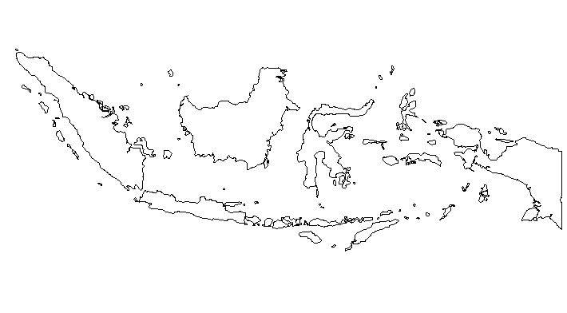

TALKING ABOUT ISLANDS

For your task you need to be able to say three things about your island.

Contoh:

Pulau ini namanya pulau Halmahera. This island is called Halmahera.
Ibu kota pulau Halmahera namanya Sofifi. The capital of Halmahera is Sofifi.
Kira-kira 163,000 orang tinggal di pulau Halmahera. About 163,000 people live on
Halmahera.
Pulau Halmahera indah dan cukup besar. Halmahera is beautiful and quite big.

Can you work out from these sentences how to say ….

this island is called
the capital city of about/approximately
live on/in beautiful
quite big

What other adjectives (describing words) would be useful for islands in Indonesia?

big interesting
small amazing
far from fantastic
near to poor
beautiful green
remote different from
old new

Try some translations! Here are two paragraphs in English about Indonesian islands. Can you translate them into correct Indonesian?

This island is called Rote island. The capital of Rote island is the city of Ba’a. About 120,000 people live on Rote island. Rote is very small and very poor.

This island is called Nias island. The capital of Nias is Gunungsitoli. About 760,000 people
live on Nias island. Nias island is small but very interesting.

ETHNIC GROUPS IN INDONESIA
Indonesia is an amazingly diverse country. It has more than 300 different ethnic groups, who are mostly native Indonesians (not migrants). Each ethnic group has its own dialect or even different language, as well as speaking Indonesian. It also has its own cultural customs, celebrations and traditional clothing. See below for the names of the more well-known Indonesian ethnic groups.

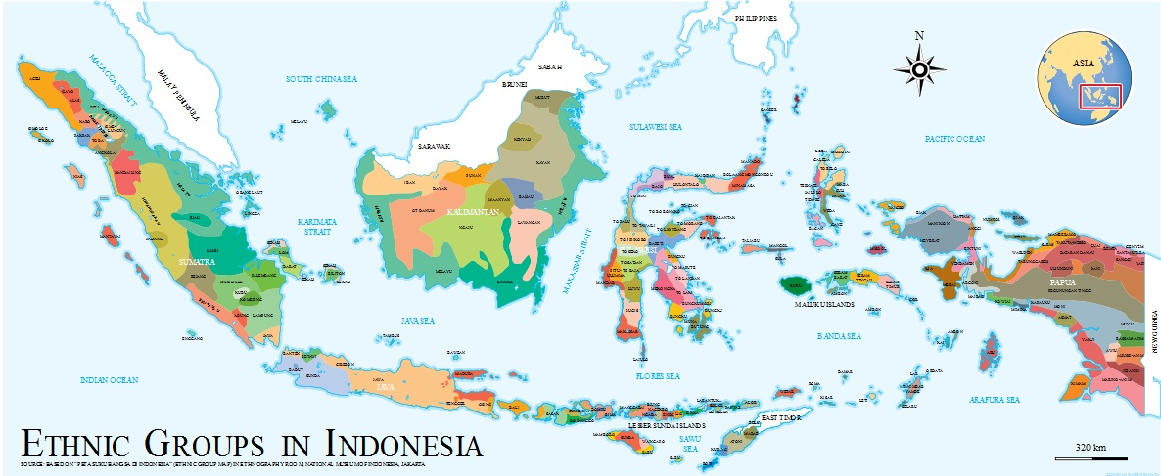

orang Bali  orang Batak  orang Banten  orang Betawi  orang Bugis | Balinese (Bali)  Bataks (Sumatra)  Bantenese (West Java)  Betawi (Jakarta)  Bugis (Sulawesi) | orang Cirebon  orang Dayak  orang Jawa  orang Madura  orang Makassar | Cirebonese (Cirebon)  Dayak (Kalimantan)  Javanese (Java)  Madurese (Madura)  Makassarese (Sulawesi) | orang Minangkabau  orang Papua  orang Sasak  orang Sunda  orang Toraja | Minangkabau (Sumatra)  Papuan (Papua)  Sasak (Lombok)  Sundanese (West Java)  Torajan (Sulawesi)

ETHNIC GROUPS

To say what ethnic group somebody belongs to you need to say orang (person)+ the name of the ethnic group.

E.g. orang Bali, orang Jawa, orang Papua

Indonesians are very proud of their ethnic groups. You will often hear a conversation like this when people first meet:

Hartanto Kenalkan Pak, saya Hartanto. Siapa nama Bapak?
Sinaga Kenalkan, saya Sinaga. Bapak orang apa?
Hartanto Oh saya orang Jawa. Dan Bapak?
Sinaga Saya orang Batak.

Mr Hartanto doesn’t need to say where he comes from because he’s told Mr Sinaga he’s a Javanese (obviously he comes from Java). Mr Sinaga doesn’t need to say where he comes from because all Indonesians know that Batak people come from North Sumatra.

But let’s add a bit just to practise working out where the ethnic groups come from. Here’s an example:

Dewi Kenalkan, saya Dewi. Siapa namamu?
Mia Nama saya Mia. Kamu berasal dari mana?
Dewi Oh saya dari Jawa Barat. *Jawa Barat = West Java
Mia Jadi kamu orang Sunda, ya?
Dewi Betul, dan Mia berasal dari mana?
Mia Saya dari Sumatra Barat *Sumatra Barat = West Sumatra
Dewi Ah jadi kamu orang Minangkabau ya?
Mia Iya.

Practise this conversation with your partner. Fill the blanks with your name, information from page 6 – first an island (or part of an island) and second an ethnic group.

Student A Kenalkan, nama saya _____________. Siapa namamu?
Student B Nama saya ____________. Kamu berasal dari mana?
Student A Oh, saya dari _______________________
Student B Jadi kamu orang ___________________ ya?
Student A Betul. Dan _________________ berasal dari mana?
Student B Saya dari __________________
Student A Ah jadi kamu orang ______________________ ya?
Student B Iya.

PAKAIAN ADAT (traditional clothing)

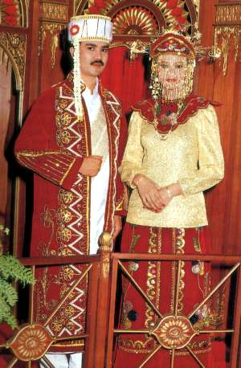 | 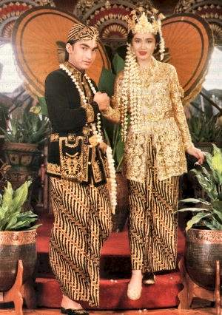 | 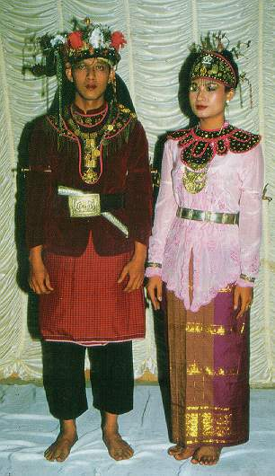
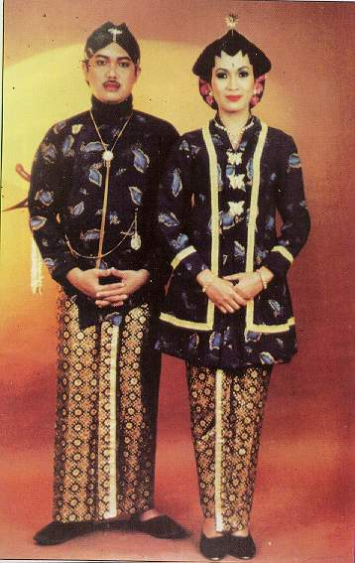 | 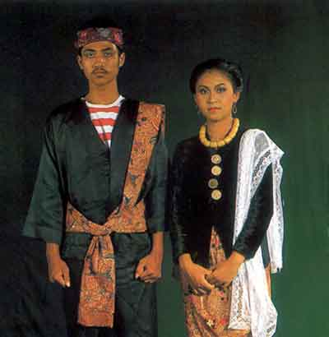 | 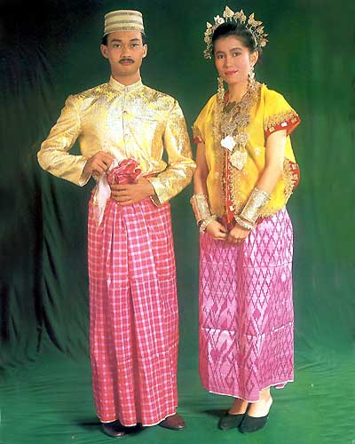
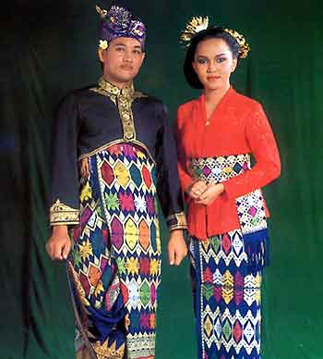 | 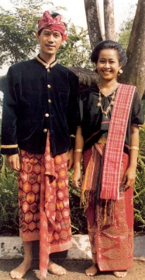 | 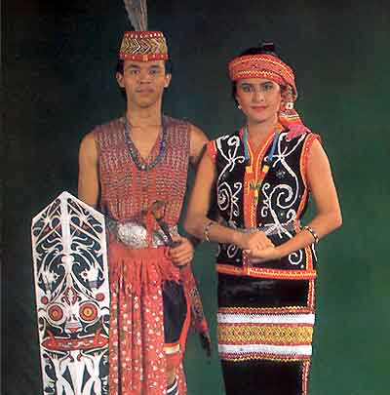
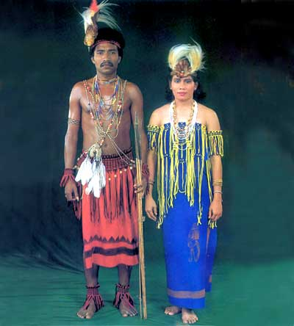 | 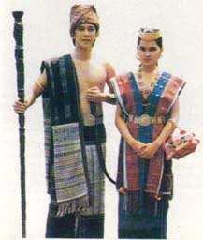 | 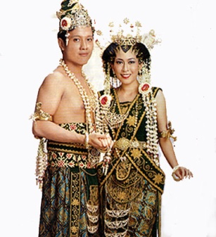
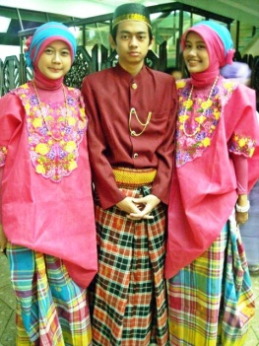 | 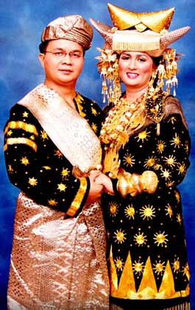 | 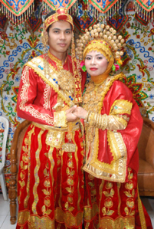

I AM … YOU ARE … HE IS …. SHE IS …

When you want to say “I am a Balinese person” or “he is a Javanese person”, for example, you have to remember that in Indonesian the words “am”, “are” and “is” are not used.

Contoh:

Saya orang Bali. I am a Balinese person / I am Balinese
Dia orang Jawa. He is a Javanese person / He is Javanese

The only words you need are these:

Saya = I, I am
Kamu = you, you are
Anda = you, you are (polite)
Dia = he, she, he is, she is
Kami = we, we are
Mereka = they, they are

Now write these in Indonesian.

1. I am a Bugis person.
2. You are a Madurese person.
3. He is a Sundanese person.
4. She is a Papuan person.
5. We are Makassanese people.
6. They are Dayak people.

This structure works with nationalities too. Just put orang in front of the country name.

Contoh:

Saya orang Australia. I am an Australian / I am Australian.
Kamu orang Amerika. You are an American / you are American.
Dia orang Cina. He is a Chinese person / he is Chinese.

Inggris  Perancis  Itali  Jerman  Amerika  Spanyol | England (UK)  France  Italy  Germany  America (USA)  Spain | Cina  Jepang  Indonesia  Malaysia  Filipina  Thailand | China  Japan  Indonesia  Malaysia  Philippines  Thailand

6. I am German.
7. You are Indonesian.
8. She is Italian.
TALKING ABOUT LANGUAGES

It’s just as easy to say what language somebody speaks. You just put the word bahasa (language) in front of the ethnic group or the country name.

Contoh:

Ethnic group/country Person Language
Bali orang Bali bahasa Bali
Batak orang Batak bahasa Batak
Bugis orang Bugis bahasa Bugis
Perancis orang Perancis bahasa Perancis
Jepang orang Jepang bahasa Jepang
Indonesia orang Indonesia bahasa Indonesia

So you can write these three things about yourself:

- Saya berasal dari Australia. I’m from Australia
berasal dari = (to) come from
berbicara = (to) speak
- Saya orang Australia. I’m Australian.
- Saya berbicara bahasa Inggris. I speak English.*

* remember, there’s no such language as “Australian”! Americans and Canadians speak English too.

How would you write the following:

9. I’m from Java. I’m Javanese. I speak Javanese.

10. You are from Papua, so (jadi) you’re Papuan. Of course (tentu saja) you speak
Papuan.

11. He’s from Germany, so he’s German. Of course, he speaks German.

12. We are from China, so we are Chinese. Of course, we speak Chinese.

13. They are from Indonesia, so they are Indonesian. They speak Indonesian and
Javanese.

TEMPAT-TEMPAT MENARIK

How many interesting places can you name in Indonesia? How many have you visited? Here are a few of the most famous …

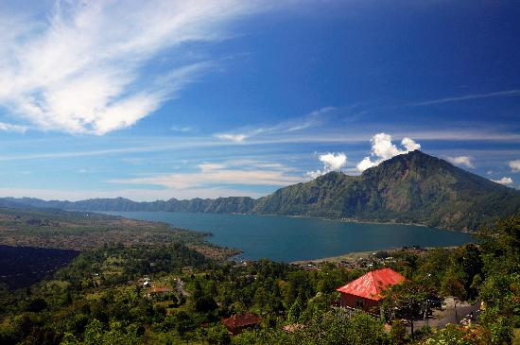 | 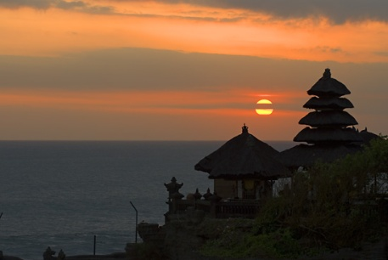 | 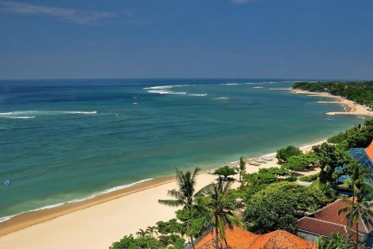
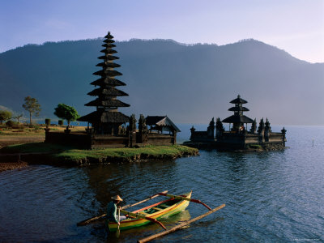 | 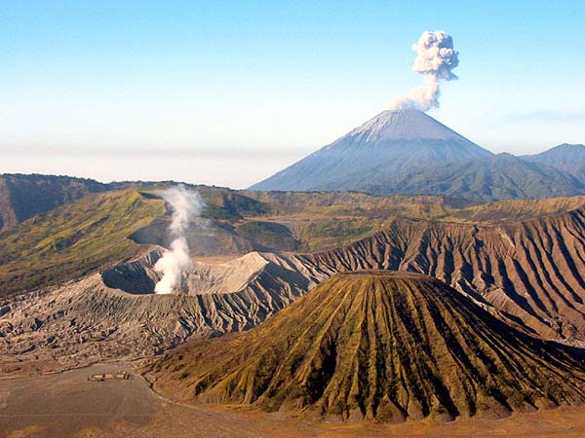 | 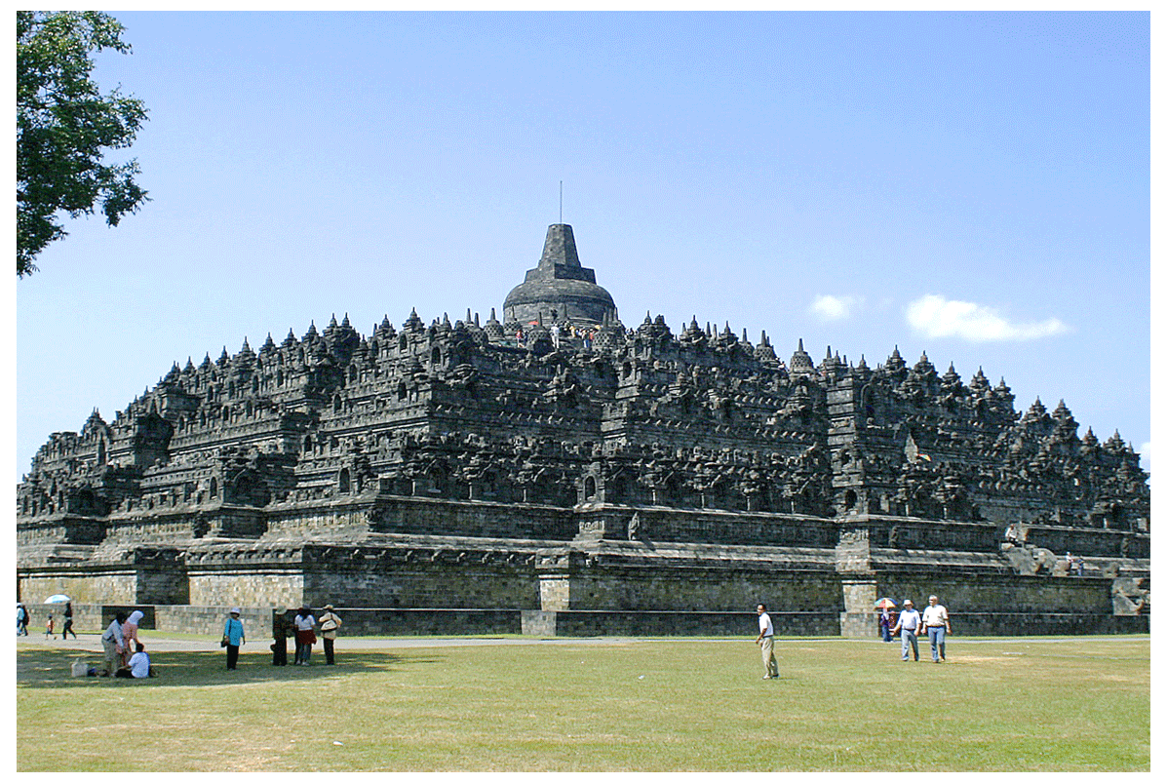
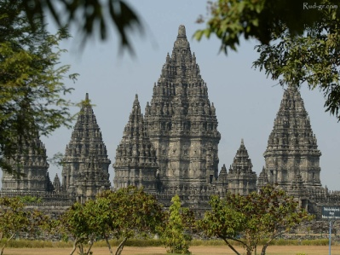 | 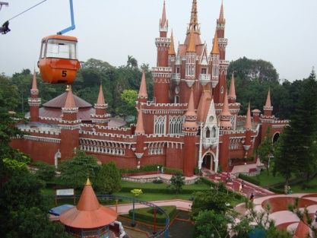 | 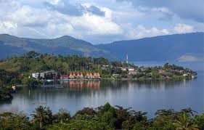
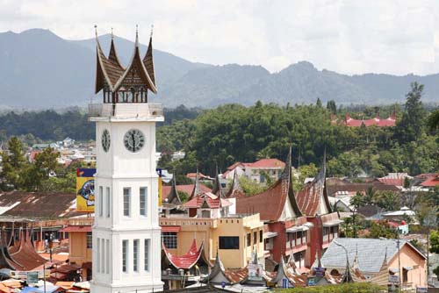 | 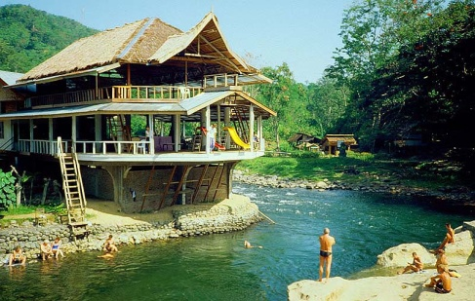 | 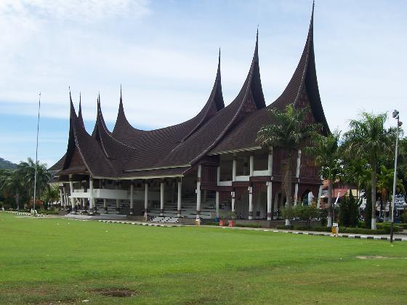
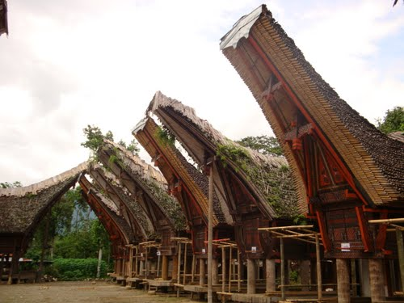 | 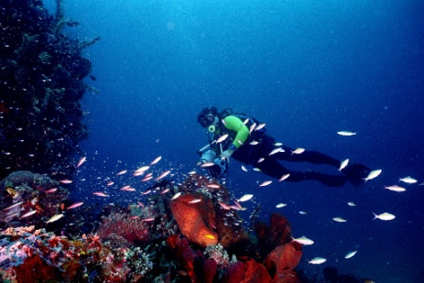 | 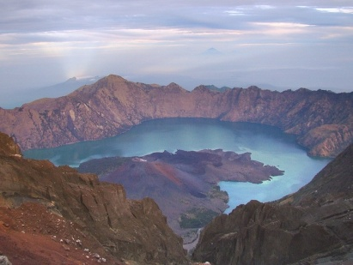

DESCRIBING WHERE THINGS, PLACES AND PEOPLE ARE

You will need to make a playing card about interesting places on the island you have chosen. So you need to be able to name the places, say where they are and describe them in a simple way (remember the adjectives on page 7 will be useful).

Contoh:

Candi Prambanan ada di pulau Jawa, dekat (near) kota (the city of) Yogyakarta. Candi Prambanan besar, tua dan mengagumkan.

Prambanan temple is on the island of Java, near the city of Yogyakarta. Prambanan temple is big, old and amazing.

Gunung (Mount) Rinjani ada di pulau Lombok. Gunung Rinjani tinggi, menarik dan indah.

Mount Rinjani is on the island of Lombok. Mount Rinjani is tall, interesting and beautiful.

Taman Mini ada di kota Jakarta, pulau Jawa. Di Taman Mini ada banyak (lots of) tempat menarik.

Mini Park is in the city of Jakarta, on the island of Java. At Mini Park there are lots of interesting places.

Write these in Indonesian:

1. Ulun Danu Temple is on the island of Bali, far from the city of Denpasar. Ulun Danu
temple is very beautiful.

2. Bunaken national park is near the island of Sulawesi. Bunaken national park is very
interesting and beautiful.

3. The city of Bukittinggi is in Sumatra. In Bukittinggi there are lots of interesting places.

BUDAYA (culture)

What exactly is culture? Can you describe what Australian culture is? Can you describe what your culture is? The key to understanding and appreciating another culture is to realise what your own culture is all about! Let’s have a brainstorm. How many dot points can you think of that really illustrate Australian and Indonesian culture?

Budaya Australia | Budaya Indonesia

While Indonesian culture belongs to the whole country, and everybody shares it, the various Indonesian ethnic groups are very proud of their own culture as well. They usually define their culture in these categories:

- pakaian adat = traditional clothing/costume
- masakan = cooking/dishes
- tarian = dance

Contoh:
 | 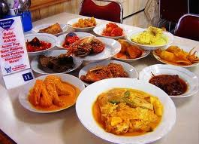 | 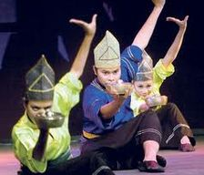
Pakaian adat orang Minangkabau berwarna hitam, kuning dan emas. | Masakan orang Minangkabau namanya masakan Padang. Enak dan pedas sekali. | Tarian Minangkabau indah dan menarik sekali. Musiknya bagus dan santai.

DESCRIBING CULTURE

To make your playing card about Budaya you need to be able to say the following:

Pakaian adat orang …… = the traditional dress of the ….. people
Masakan orang …. = the cooking of the …. people
Tarian orang …… = the dance of the …. people

Then you can add on a description. Here are some words that “fit” the three descriptions.

Pakaian adat |  | Masakan |  | Tarian
berwarna  merah  kuning  hijau  biru  coklat  hitam  emas  perak  putih  abu-abu  ungu  jingga | is coloured  red  yellow  green  blue  brown  black  gold  silver  white  grey  purple  orange | enak  lezat  pedas  kurang pedas  berbasis nasi  asin  manis  menarik  luar biasa  kurang biasa  berbeda | delicious  delicious  hot & spicy  not spicy  based on rice  salty  sweet  interesting  wonderful  unusual  different | indah  menarik  sulit  lama  singkat  menyenangkan  membosankan  musiknya  bagus  menghibur  santai  cepat  pelan | beautiful  interesting  difficult  long  short  fun  boring  has good  music  entertaining  relaxing  fast  slow

How would you write:

1. The traditional dress of the Balinese people is coloured red, black and white.

2. The cooking of the Batak people is unusual but (tetapi) delicious.

3. The dance of the Javanese people is very slow but also (juga) beautiful.

TIME TO PREPARE YOUR CARDS!

1. Make sure you have completed the planning chart on page 4.

2. Use the following templates to write the Indonesian version of each of your cards –
Pulau, Orang, Tempat-tempat, Budaya. Write in full sentences, and write 3-4
sentences for each card. Use this booklet to work out how to write the information!

3. Create a Word document on the computer with a 2 x 2 table.

4. Find four (4) images on the Internet, one for each cell of your table, and adjust their
sizes to fit.

5. Under each image, add the Indonesian sentences you have written.

6. Get the teacher to check your work.

7. Save your work and email to the teacher, who will print it for you to laminate next
lesson.

8. Laminate and cut out your cards. When everyone else has done the same, you are
ready to play!

TEMPLATES

PULAU …..  image  _____________________________________  _____________________________________  _____________________________________  _____________________________________  _____________________________________  _____________________________________  _____________________________________  _____________________________________  _____________________________________  ____________________________________ | ORANG ….  image  ____________________________________  ____________________________________  ____________________________________  ____________________________________  ____________________________________  ____________________________________  ____________________________________  ____________________________________  ____________________________________  ____________________________________

TEMPAT-TEMPAT …..  image  _____________________________________  _____________________________________  _____________________________________  _____________________________________  _____________________________________  _____________________________________  _____________________________________  _____________________________________  _____________________________________  ____________________________________ | BUDAYA ….  image  ____________________________________  ____________________________________  ____________________________________  ____________________________________  ____________________________________  ____________________________________  ____________________________________  ____________________________________  ____________________________________  ____________________________________

IMAGE ACKNOWLEDGEMENTS

Cover images:
http://www.asiaeducation.edu.au/sites/goindonesia/index.htm

Page 3
http://www.peanutgallery.com.au/catalogue/kids_games/card_game_go_fish/image/?size=3000x3000&helper=1348186596.64
http://members.ozemail.com.au/~slacey/images/bali%20map.gif
http://cdn.c.photoshelter.com/img-get/I0000SO3br196AOI/s/880/880/Balinese-People-Rice-farmer-woman-Tanah-Lot-temple-Tabanan-bali-indonesia-9023.jpg

http://lh3.ggpht.com/stojanoskislave/R_9n5IKX9ZI/AAAAAAAAG3A/l16kVm7CBuM/LAND084.jpg?imgdl=1

Page 4
Indonesia Raya lyrics:
http://www.lyricsondemand.com/miscellaneouslyrics/nationalanthemslyrics/indonesianationalanthemlyrics.html

Page 7
http://0.tqn.com/d/geography/1/0/m/J/indonesia.jpg

Page 9
http://multiply.com/mu/bambangpriantono/image/29/photos/6/500x500/81.jpg/Betawi-wedding-dress.jpg?et=CWiPMeN9h8OLjW7nSjyFkQ&nmid=897299
http://multiply.com/mu/bambangpriantono/image/34/photos/6/500x500/85.jpg/Sundanese.jpg?et=QbQ5rwsmuGJtkKOI3DK0bg&nmid=897299
http://i37.photobucket.com/albums/e74/sylvdoanx/costume_medan2.jpg
http://1.bp.blogspot.com/_bftTadpPB7w/TGi7RHlC6JI/AAAAAAAAAUY/Jw2YzTPaZq8/s1600/DSCN10500.JPG
http://www.pelaminanminang.com/wp-content/themes/minang/slide-img/tanduk_ameh_bintang_pelaminan_minangkabau.jpg
http://sphotos-h.ak.fbcdn.net/hphotos-ak-ash3/560632_391692390852798_1605731170_n.jpg
http://arya616.files.wordpress.com/2012/10/1047408_setframe_1.jpg?w=201&h=300

Page 13
http://4.bp.blogspot.com/-YB5T5W4oCmw/Tgl2InmSnuI/AAAAAAAACE8/qyyt4-LVKFw/s1600/lake-batur.jpg
http://2.bp.blogspot.com/_jrEQBxD-3t8/S8QotcPSzsI/AAAAAAAAAGQ/ewCw7MrttyA/s1600/2.jpg
http://vitaapitut.files.wordpress.com/2011/11/sanur.jpg?w=1600&h=1064
http://cache2.allpostersimages.com/p/LRG/26/2659/W5DUD00Z/posters/vidler-steve-lake-bratan-pura-ulun-danu-bratan-temple-and-boatman-bali-indonesia.jpg
http://4.bp.blogspot.com/-gyd5Fh720Pk/TfZyB_m_g8I/AAAAAAAAAZ0/PjAC8JQwhCY/s640/mount.jpg
http://3.bp.blogspot.com/-5PV7iFUO40Y/UBkxFlMG60I/AAAAAAAAAKY/ZK8rWHO7rJo/s1600/borobudur+magelang.gif
http://touristspot.ruvenga.com/wp-content/uploads/2011/06/prambanan-temple1.jpg
http://1.bp.blogspot.com/-FX_Gja7HBYs/TVk0EHyRZtI/AAAAAAAAAjo/IvWcTJo5n7I/s1600/DSC02949.JPG
http://tobaexplorer.files.wordpress.com/2012/05/toba-explorer-ii-tuktuk-samosir-island-lake-toba.jpg
http://www.jittsb.com/wp-content/uploads/2012/05/bukittinggi.jpeg
http://www.rontravel.com/Web_Photos_Happy_Cannibal/F_Southeast_Asia/Indonesia_Sumatra_Bukit_Lawang.jpg
http://www.grandsakurahotel.com/dest_images/Padang1.jpg
http://mw2.google.com/mw-panoramio/photos/medium/31147372.jpg
http://1.bp.blogspot.com/-JRQWUUPyG8k/UG45c_jkkxI/AAAAAAAAAQw/C8-iP_Pr8sk/s1600/Bunaken1.jpg
http://i.images.cdn.fotopedia.com/flickr-2832896106-image/Volcanoes/Volcanic_landforms/Volcanic_cone/Stratovolcano/Mount_Rinjani/Rayos_anticrepusculares_en_el_Gunung_Rinjani_Lombok.jpg
http://zulfadli.files.wordpress.com/2007/06/masakan_padang.jpg

Page 15
http://zulfadli.files.wordpress.com/2007/06/masakan_padang.jpg
http://images.travelpod.com/tripwow/photos/ta-06eb-975c-5472/tarian-minang-negeri-sembilan-malaysia+1152_13528842414-tpfil02aw-9828.jpg

