INDONESIAN X NAME
Reading Assessment

Read this information about a Dayak boy and his island and community, and answer the questions after it in English.

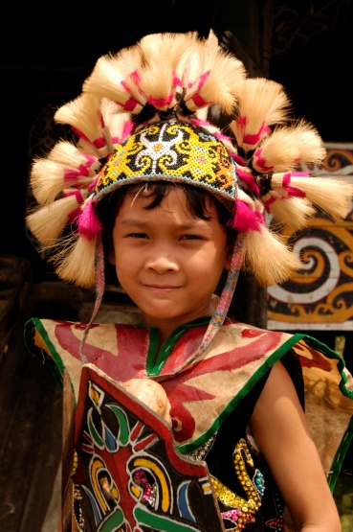
Hai nama saya Ampong. Saya orang Dayak dan saya berasal dari pulau Kalimantan. Saya berbicara bahasa Dayak dengan ibu, bapak dan kakak saya, dan bahasa Indonesia di sekolah dengan ibu guru.

Orang Dayak suka memakai pakaian adat. Pakaian adat saya berwarna coklat muda, merah, kuning dan hijau. Bagus ya?

Pulau Kalimantan besar sekali dan menarik. Kira-kira empatbelas juta tiga ratus ribu orang tinggal di pulau Kalimantan. Satu kota besar di pulau Kalimantan namanya Balikpapan.

Masakan orang Dayak lezat sekali dan menyenangkan. Masakan itu berbasis ayam, santan¹ dan sayur. Tarian orang Dayak juga sangat menarik. Tarian itu cukup cepat tetapi tidak sulit. Musiknya bagus sekali.

Di pulau Kalimantan ada hutan yang besar sekali dan indah. Banyak monyet dan burung tinggal di hutan. Ada juga gunung Meratus yang tinggi sekali dan menarik.
¹santan = coconut milk

1. Give four (4) pieces of information about Ampong (apart from his name).

2. Complete the chart below with information about Kalimantan.
Adjectives used to describe it

Population

What Balikpapan is

3. Complete these sentences with information about Dayak cooking.

Dayak cooking is _________________________ and _________________________
Dayak cooking contains _____________________, ___________________________
and ____________________________

4. Give four (4) pieces of information about Dayak dancing.

5. Write as much information as possible about some places to visit in Kalimantan.

INDONESIAN X NAMA
Writing Assessment

Below are some pictures of an island and its people and culture. Pretend you are one of the boys in the photo and write an introduction in Indonesian for students living on other Indonesian islands to read. Include all the information shown in the photos, and use your imagination to describe it if you have to guess what something is like. (You don’t have to fill up the whole space!).

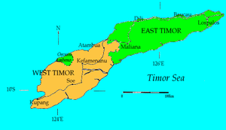 | 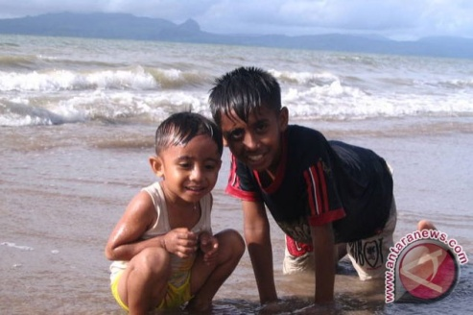 | 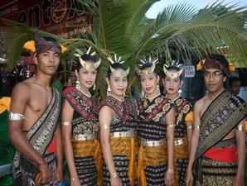
Timor Island | Joseph & Lukius | Traditional Timor Clothing
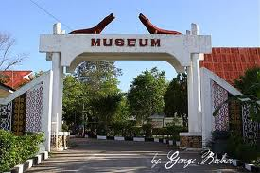 |  | 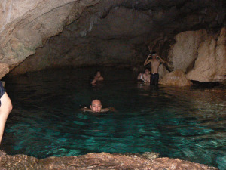
Kupang Museum | 1,600,000 people | Goa Kristal (Crystal Cave)
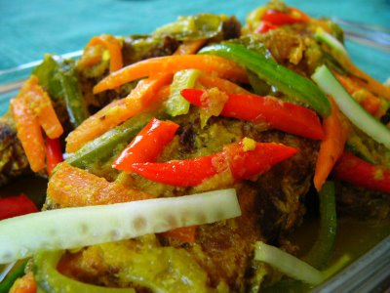 | 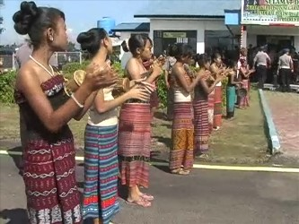 | 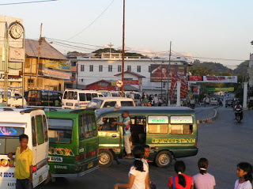
Timor Cooking | Timor Dancing | City of Kupang

INDONESIAN Y NAME
Marking Key (55 marks) 14%

1. Give four (4) pieces of information about Ampong (apart from his name). (4 marks)
- he’s a Dayak person
- he comes from Kalimantan
- he speaks Dayak language with his family
- he speaks Indonesian at school
2. Complete the chart below with information about Kalimantan. (6 marks)
Adjectives used to describe it | very (1) big (1), interesting (1)
Population | 14, 300,000 (1)
What Balikpapan is | a large (1) city (1) in Kalimantan

3. Complete these sentences with information about Dayak cooking. (5 marks)

Dayak cooking is __very delicious(1)__________ and _____fun, nice (1)_____________
Dayak cooking contains ___chicken (1)____________, _____coconut milk_(1)____________
and ____vegetables (1)__________________
4. Give four (4) pieces of information about Dayak dancing. (4 marks)
- extremely interesting
- fairly fast
- not difficult
- has good music
5. Write as much information as possible about some places to visit in Kalimantan.
(11 marks)
a very (1) big (1) and beautiful (1) forest (1) / many (1) monkeys (1) and birds (1) live in
the forest / Mount (1) Meratus (1) which is very (1) high (1) and interesting (1)

6. Write about the island and people shown in pictures. (25 marks)

Content |  |  | Mark
You have included all the information shown in pictures:
- your name  - name of island  - population  - traditional clothing |  | - cooking  - dancing  - city of Kupang  - Kupang Museum  - Goa Kristal | /9
You have added at least 1 extra piece of information (e.g. an adjective) to the following: |  |  | /6
- island description  - people description  - clothing description | - food description  - dancing description  - city description
You have used correct vocabulary in your writing. |  |  | /5
You have used correct sentence structure in your writing. |  |  | /5
TOTAL MARKS |  |  | /25

